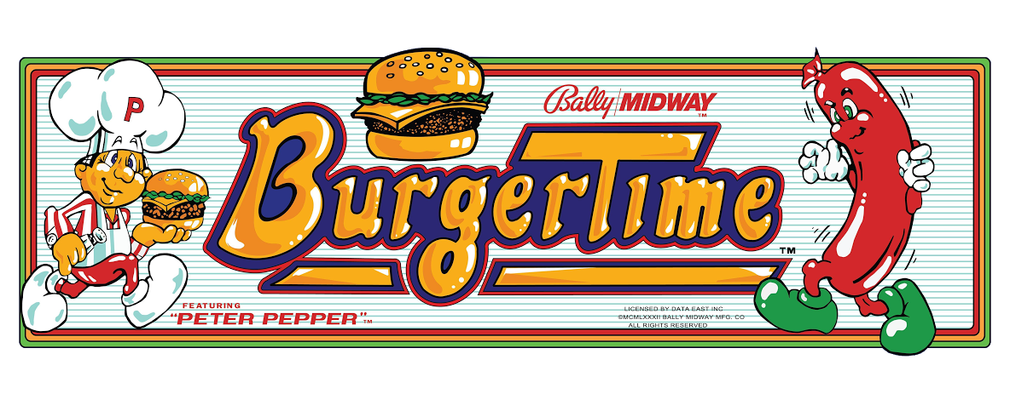

USER GUIDE

Program STORY/ GOALS:

BurgerTime is a fun retro game that involves Peter pepper getting his burgers back from the evil Mr. Hot dog and his friends. More found in characters subheading.

Characters:

Peter Pepper – Our main hero, Peter, has lost his burger parts scattered across his vents (or so he thinks).

Mr. Hot Dog – Mr. hot Dog is the antagonist in this suspenseful story of life and death. He and his friends scattered Peter’s burger and will do anything to make sure Peter does not get his burgers back as he feels like an outcast at his lunch-only diner.

Program Controls:

Right – move right Up – move up ladder

Left – move left

Space – pepper spray hot dog Down – move down ladder

Score Output:

The Score will be shown at the top of the screen under “Score”.

Burger part down – 50 points

Burger Part gets to plate – 100 points

Destroy hot dog with burger part – 300 points

Pepper spray hot dog – 200 points

Lives will be taken away if you come in contact with a hot dog while you are on the platform (ladders are safe unless you are on the exact level as the platform).

You start every game with one pepper and if you are within spraying distance of a hot dog, you can shoot it and kill it.

Application of programming concepts:

Ifs – platform collisions, burger collisions, hot dog collisions, moving up and down ladders, arrow moving in title and game over and win screen, winning conditions, printing instructions only once, pepper display, scoring, player and hot dog animations

Loops – while loop running while in game, Various for loops to reference the lists of hot dog coordinates and burger coordinates and pepper

Lists – storing burger and hot dog coordinates, storing platforms that burgers fall on once dropped or touched by another burger part

Functions – To display images of peter pepper, Mr. Hot dog, pepper, burger parts, scoring system, lives, moving arrow, score, and pepper

Image references:

Logo – https://www.geocaching.com/geocache/GC5BE24_arcade-gems-1-burgertime?guid=7ac2d7d4-662e-4cc0-b74a-ea846c3c3b31

Level one screen – https://en.wikipedia.org/wiki/BurgerTime

Title Screen – https://www.youtube.com/watch?v=SyG3Tesw2CA

Start screen – http://www.rickandviv.net/index.php/intellivision-games-on-an-arcade-cabinet/burgertime/

Numbers – http://randomhoohaas.flyingomelette.com/Sprites/spr-other.php

Characters – http://gsarchives.net/nes/burger_time/sprites/

Flow Chart:

C:\Users\tardisbreaker\Downloads\BurgerTime.png

Visual Sketch:

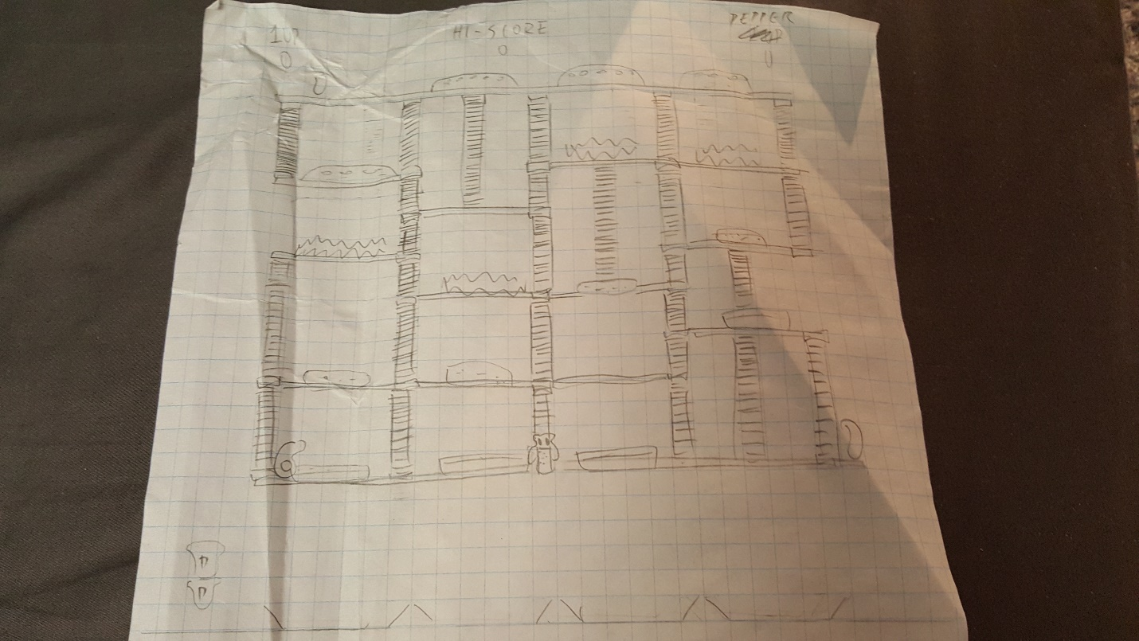

Test Plan:

|  |  |  |
| --- | --- | --- |
| Code | Expected | Actual |
| arrow() | Shifts up and down on title, game over, and win screen (with minor delay). | Shifts up and down on title, game over, and win screen with minor delay. |
| player() | Changes player picture according to number of rights, lefts, ups, or downs that the player has accumulated. | Changes player picture according to number of rights, lefts, ups, or downs that the player has accumulated. |
| burgerTop() | Displays all burger tops according the x and y coordinates changed and sent in the while loop. | Displays all burger tops according the x and y coordinates changed and sent in the while loop. |
| green() | Displays all lettuces according the x and y coordinates changed and sent in the while loop. | Displays all lettuces according the x and y coordinates changed and sent in the while loop. |
| patty() | Displays all beefs according the x and y coordinates changed and sent in the while loop. | Displays all beefs according the x and y coordinates changed and sent in the while loop. |
| burgerBottom() | Displays all burger bottoms according the x and y coordinates changed and sent in the while loop. | Displays all burger bottoms according the x and y coordinates changed and sent in the while loop. |
| hotdog() | Changes hot dog picture according to whether it’s moving left or right. | Changes hot dog picture according to whether it’s moving left or right. |
| scoring(scorenumbers) | Displays score and changes according to how many burgers go down a platform, how many get to the plate and how many hot dogs defeated. | Displays score and changes according to how many burgers go down a platform, how many get to the plate and how many hot dogs defeated. |
| life() | Displays number of lives left. | Displays number of lives left. |
| shaker(scorenumbers) | Displays the pepper or lack thereof on the screen. | Displays the pepper or lack thereof on the screen. |
| redraw_screen() | If the screen is the title, it will have an arrow that shifts by pressing space and can select either the instructions or to play 1 player by pressing enter.  If the screen is the level, it will call burgerTop(), green(), patty(), burgerBottom(), player(), hotdog(), scoring(scorenumbers), life(), shaker(scorenumbers):   * Will display Peter Pepper, burger tops, lettuces, beefs, burger bottoms, hot dogs, score, lives, and pepper shakers.   If the screen is game over or win, it will display the end score and have an option to play again or exit. | If the screen is the title, it will have an arrow that shifts by pressing space and can select either the instructions or to play 1 player by pressing enter.  If the screen is the level, it will call burgerTop(), green(), patty(), burgerBottom(), player(), hotdog(), scoring(scorenumbers), life(), shaker(scorenumbers):   * Will display Peter Pepper, burger tops, lettuces, beefs, burger bottoms, hot dogs, score, lives, and pepper shakers.   If the screen is game over or win, it will display the end score and have an option to play again or exit. |